**Spring Boot Kafka Twitter Streaming**

# **Kafka :**

Apache Kafka is an open-source distributed event streaming platform used by thousands of companies for high-performance data pipelines, streaming analytics, data integration, and mission-critical applications.

Sample Kafka Demo using CMD :

1. Install Kafka server using below URL.

<https://kafka.apache.org/download>

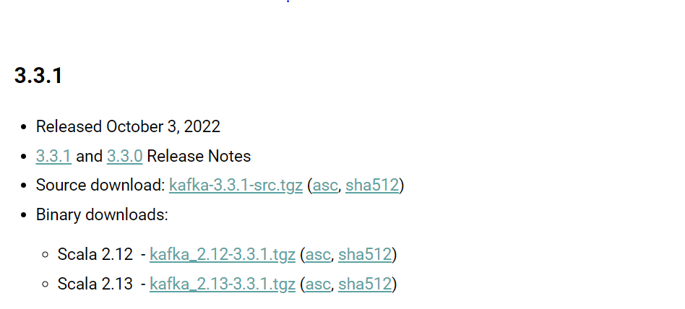

1. Extract Kafka directory.
2. Change Log Directory path in server.properties for maintaining the logs.

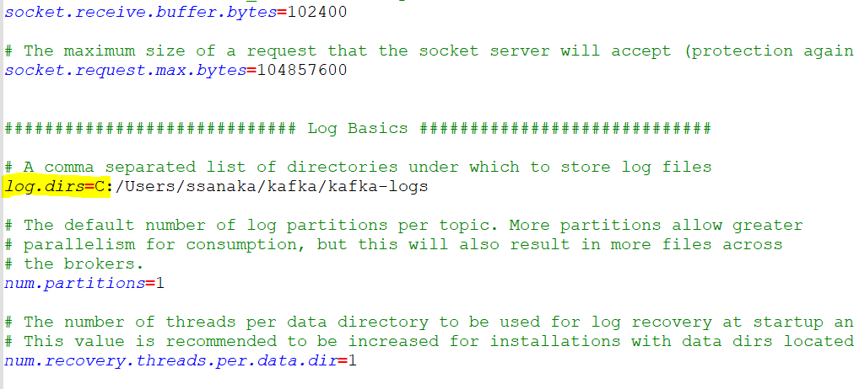

1. Change data directory path server.properties

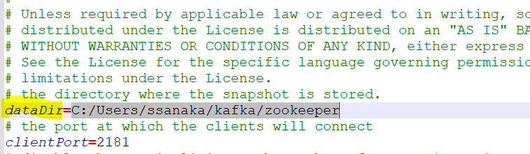

1. Un Comment the below highlighted listener in server.properties

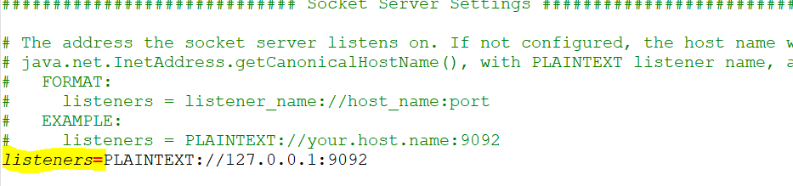

1. Navigate to Kafka Directory and run start zookeeper using below command.

* .\bin\windows\zookeeper-server-start.bat .\config\zookeeper.peroperties

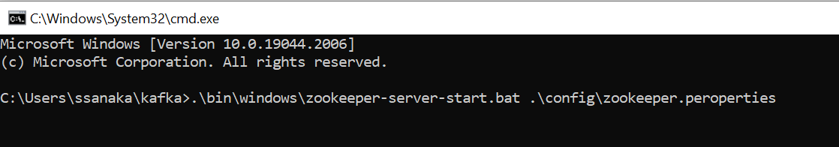

1. Start Kafka server using below command.

* .\bin\windows\kafka-server-start.bat .\config\kafka.peroperties

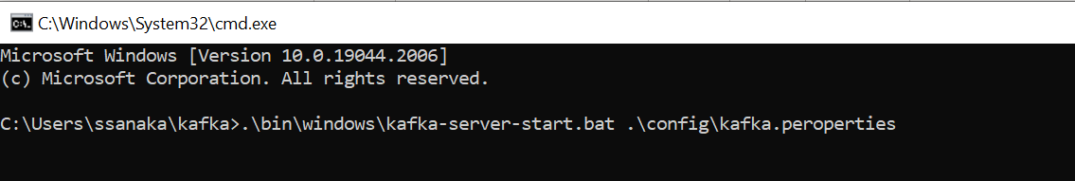

1. Create topic using below command.

* .\bin\windows\kafka-topics.bat --create --topic twitter-topic --bootstrap-server localhost:9092 --replication-factor 1 --partitions 2

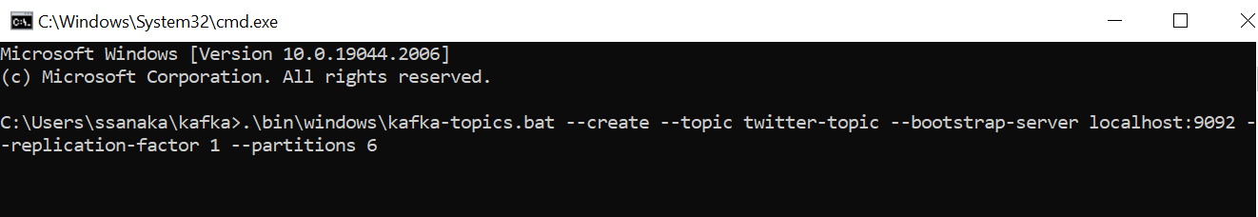

1. Create producer using below command to producer data to twitter topic.

* .\bin\windows\kafka-console-producer -bootstrap-server localhost:9092 -topic twitter topic

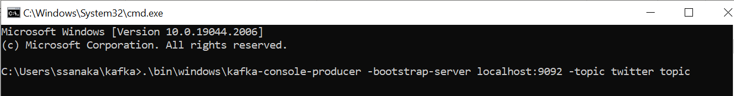

1. Create Consumer using below command to consume data from twitter topic.

* .\bin\windows\kafka-console-consumer -bootstrap-server localhost:9092 -topic twitter topic

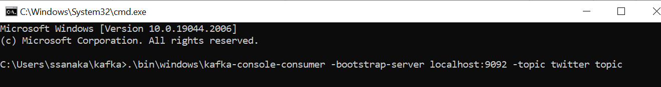

1. Producer producing data to twitter topic & Consumer consuming data from twitter topic.

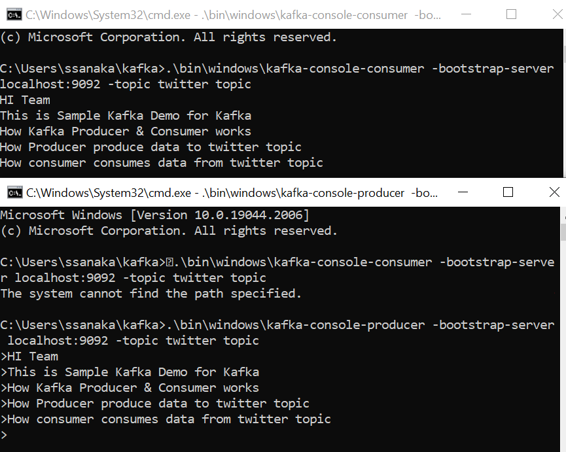

**Spring Boot Kafka Twitter Streaming**

1. Application Workflow:

###### 



1. **Application Implementation** :

1) Implemented Spring Boot Example & Added Dependency's

a) Kafka

b) hbc-core

c) Spring Starter Web

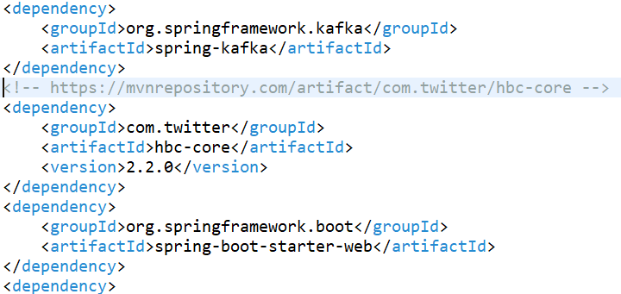

2)Add configuration data in application.properties

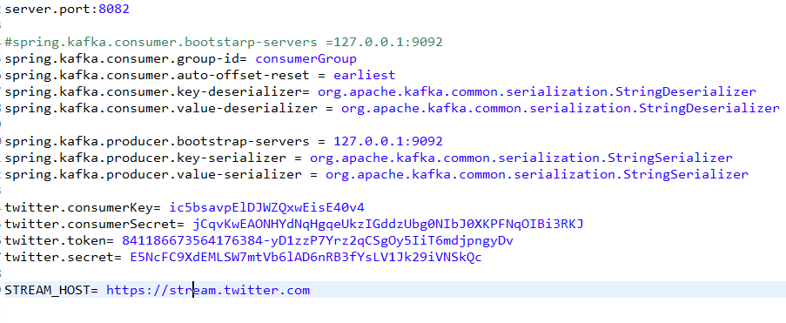

3) Implemented Rest Controller for accepting client request.

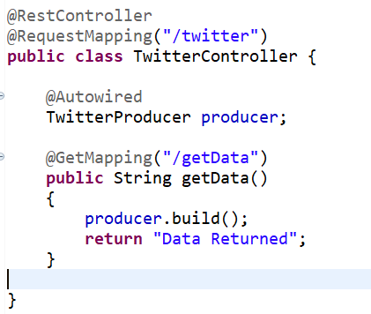

4) Implemented Configuration class to create Queue and Client.

A) created Queue and Client object for connecting Twitter Api.

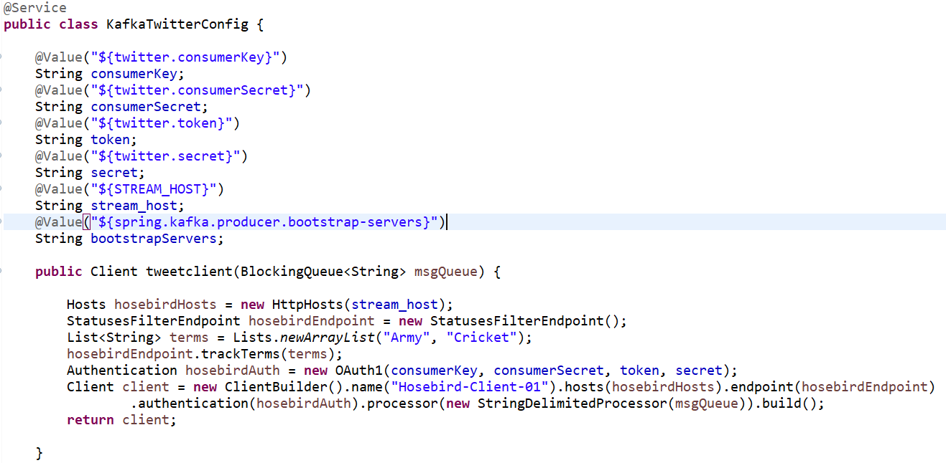

5) Create Producer Service and create **Kafka Producer**.

A) Use **Kafka Template** in producer to send data to topic.

B) Poll data from Queue and Send it producer.

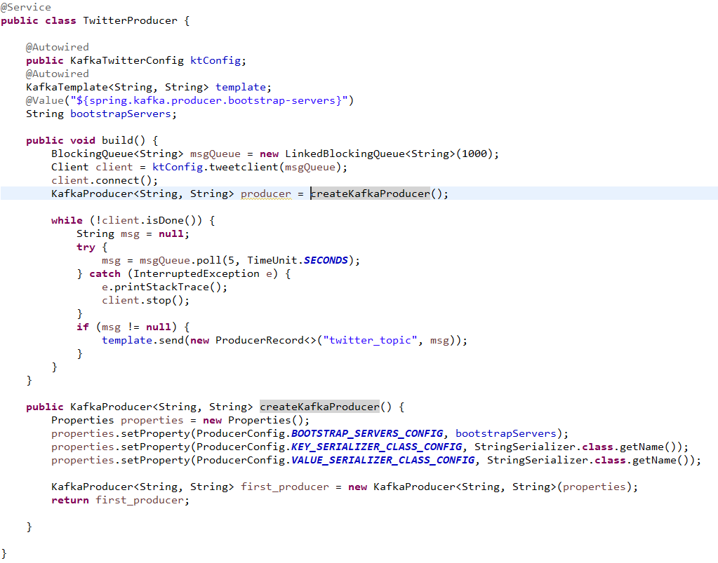

6) Create Consumer Service and create **Kafka Consumer**.

A) Use Kafka Listener in consumer to Consume Data from Topic.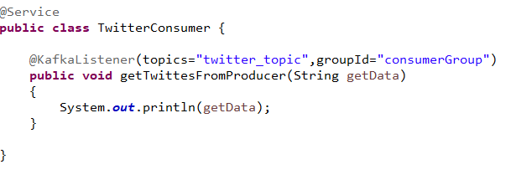

7) Run Spring Boot Application.

8) Open Postman and test application.

